Name: ______________________________ Date: _____________
Properties of Materials
T: Can I identify objects, materials and their properties?
Choose an object.
What is it? What material is it made from? What are the properties of the material?
Object:  Towel | Towels are made from cotton.  Cotton is soft and absorbent.

Object:

Object:

Object:

Object:

(see some key words on next sheet if needed)

Key Words
Materials:

Glass plastic wood cotton metal

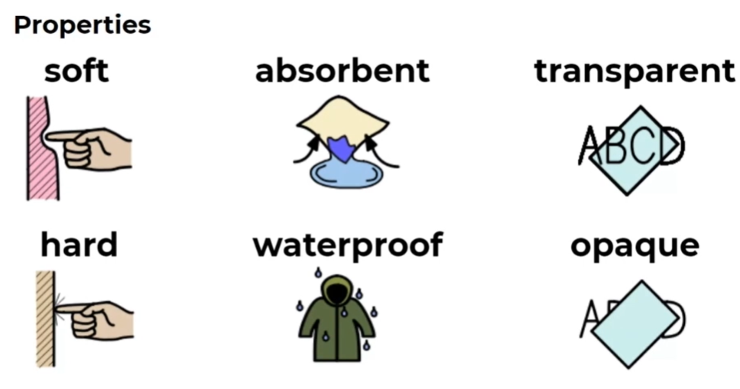

flexible / bendy shiny

